_{Zoom Windows SDK}

Modification History

Revision | Date | Originator | Comments
2 | 08/05/2016 | Zoom custom engineering | Support login zoom user
2 | 10/05/2016 | Zoom custom engineering | fix leave meeting wnd cut off issue
2 | 11/15/2016 | Zoom custom engineering | add new interface for get windows handle  fix branding issue in setting dialog, whiteboard and airhost window  fix participant id don't take effect when start/join meeting
2 | 01/20/2017 | Zoom custom engineering | Support to join Webinar meeting with as Panelist  Support to pin/spotlight video  Support to pause/resume screen sharing  Support H.323/SIP callout directly  Support invite by Phone andCall Medirectly  Add watermark - Powered by Zoom  Support to start/join meeting without audio  Support to start/join meeting without video  support Multi-share  new interface in ISettingService  new interface in IMeetingConfiguration  refine IMeetingService interface

Note that the windows SDK from Zoom is distributed under a separate SDK agreement. Please make sure that you read the terms and conditions of the SDK agreement before using the SDK.
- Introduction and Pre-Requisite
In order to use the SDK, you need to make sure that the RETS API and the mobile SDK is enabled in your account. If not, please contact your account rep or contact Zoom support. Our windows SDK is written in C++ - if you are writing a C#/.NET application, you need to make sure that you can call the C++ library functions from within your application space.

Note that our SDK support meeting services and do not support messaging currently.

- Get the SDK key and secret from your zoom account. This key/sec is same as the
one used for mobile SDK

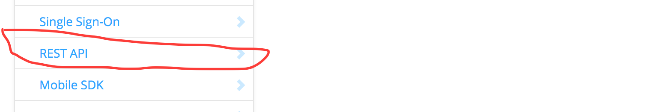

- Get the REST API Key/Sec from your zoom account

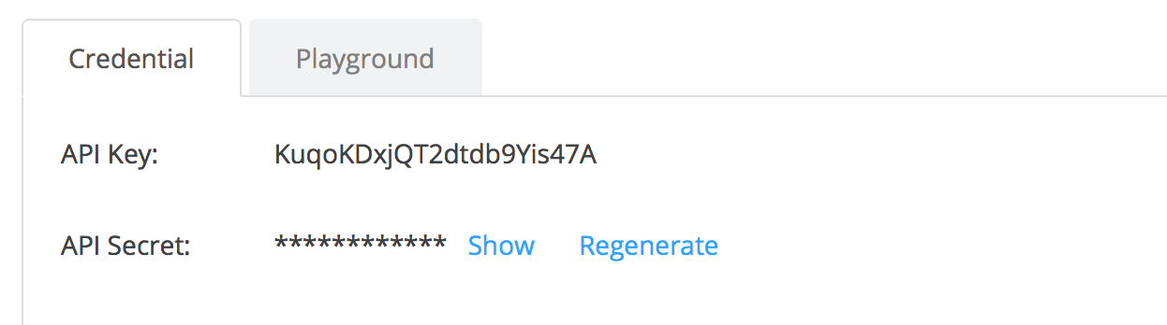

- Call REST API “getbyemail” and this should return the user id and user token

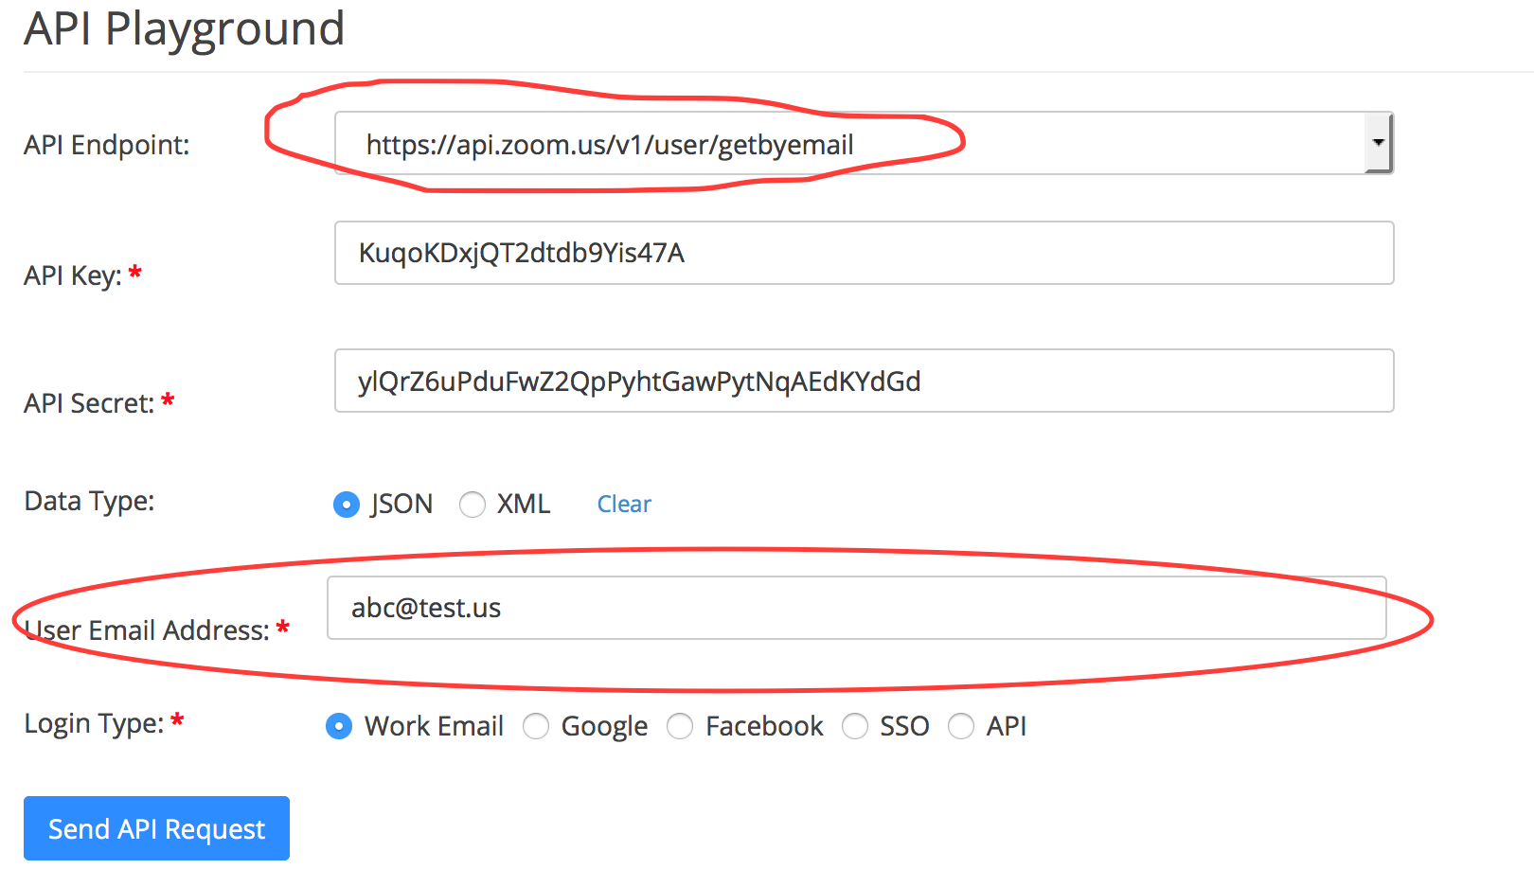

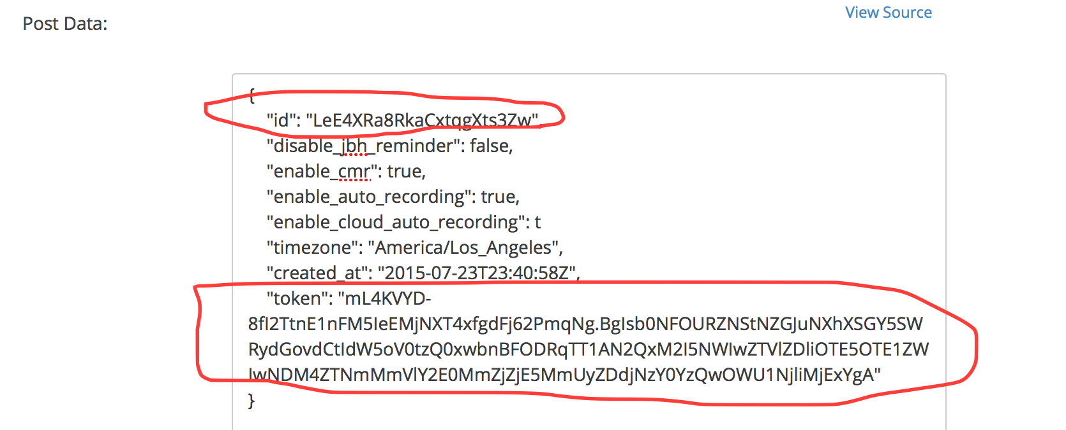

- SDK Architecture and Workflow

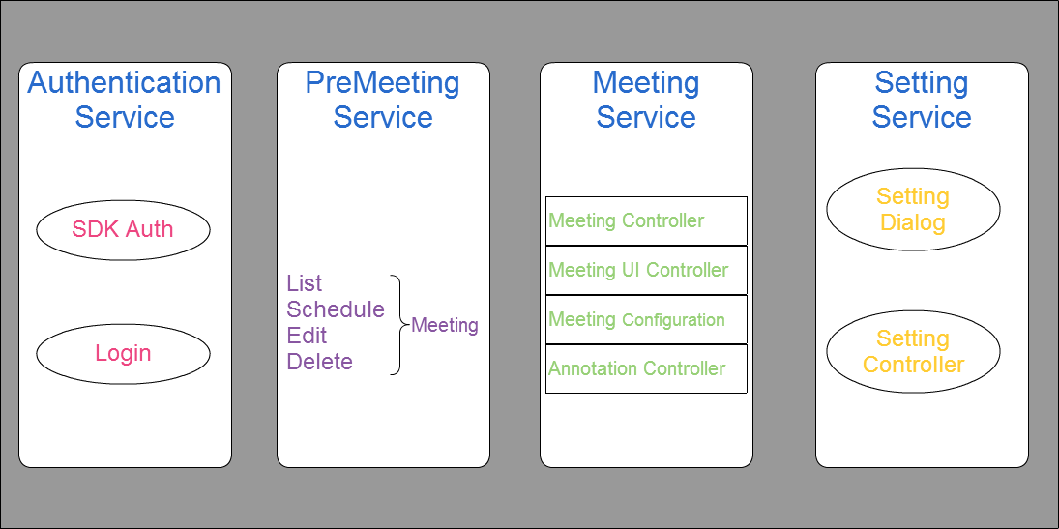

Zoom SDK supports two options for user authentication.

- You can pass the user id of the user to the SDK initialization and all the meetings will start on that user’s account. This is referred to as API user
- There are times it might be cumbersome to get the user id and you might want to distribute your app to all Zoom users – in this case, you can ask the user to enter the Zoom login credentials (username /password) in your app and then pass it to the SDK. This is referred to as normal user
- API User join/start and leave 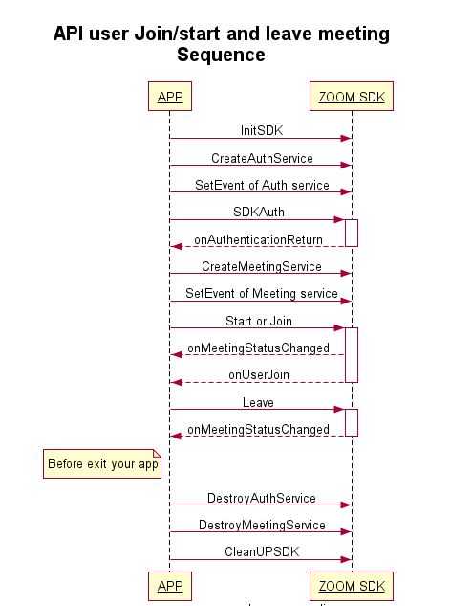

- Normal User join/start and leave meeting

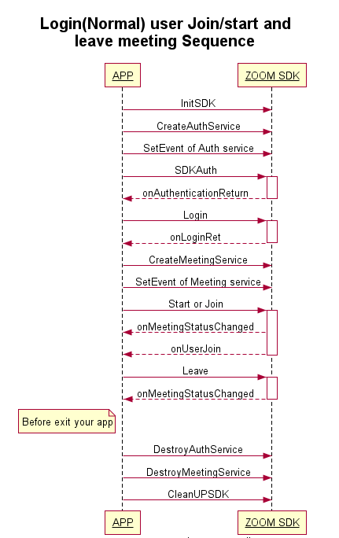

- Normal User list/schedule/edit/delete meeting

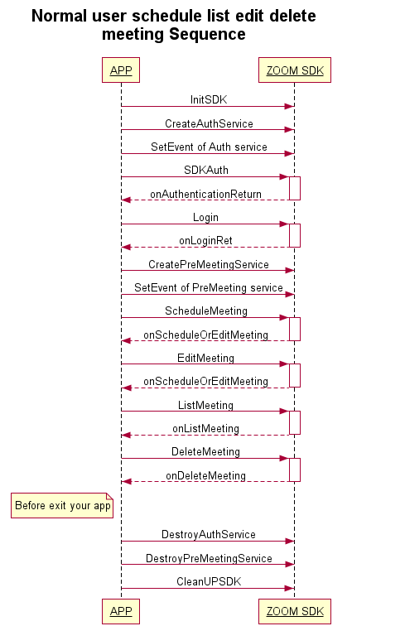

- SDK Functions

Initialization
You can find these APIs in zoom_sdk.h. Please call zoom sdk APIs in main ui thread for thread safe operation.

Initialize zoom sdk:
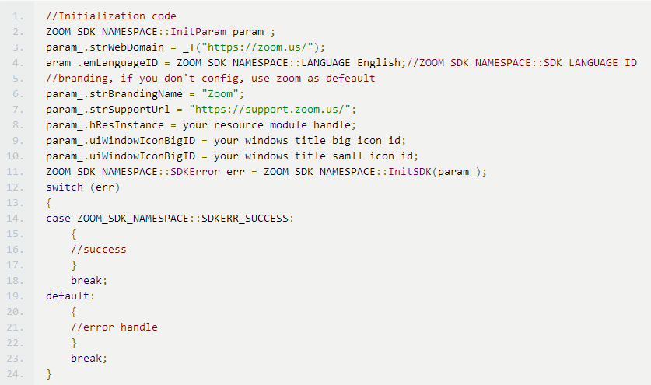

Cleanup zoom sdk before you exit your application.



Authentication Service
You should do authentication first when you start to use zoom sdk and include auth_service_interface.h

- Create authentication service
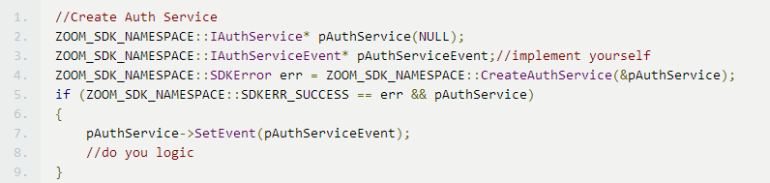

- Auth SDK
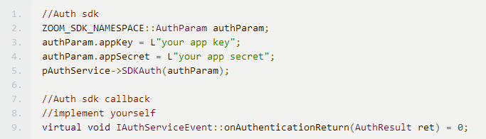

- Login end user
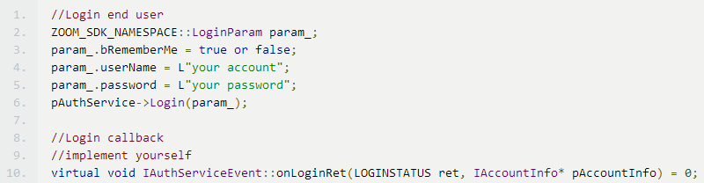

- Logout end user
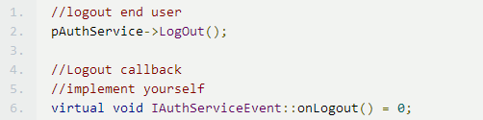
- Destroy auth service
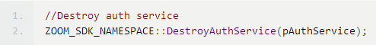

Pre-meeting Service

If you want to use this service, include premeeting_service_interface.h.

- Create Pre-Meeting Service:
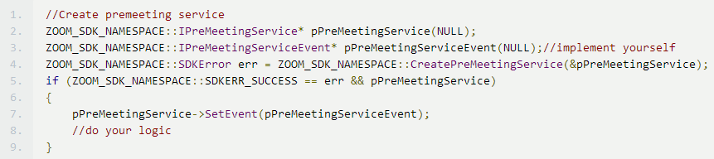

- Schedule Meeting
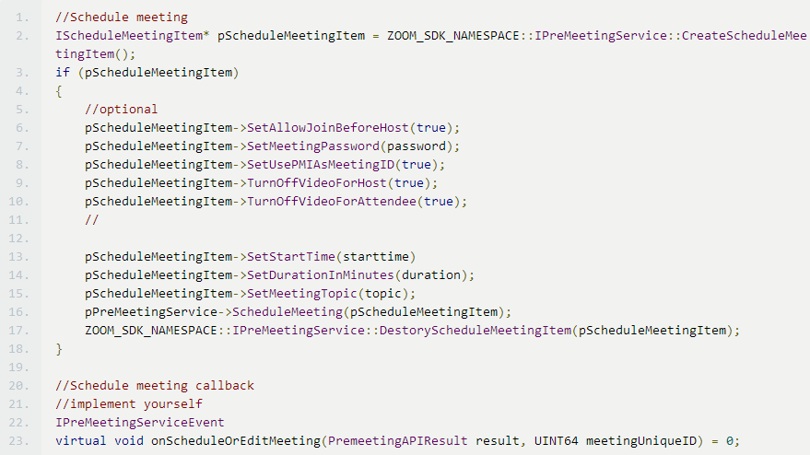

- Edit Meeting
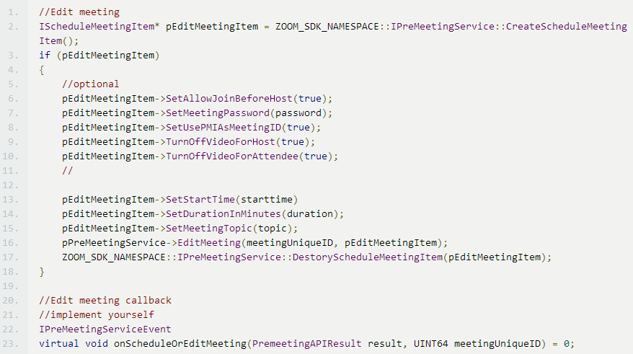

- Delete Meeting

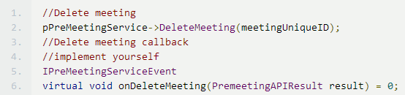

- List Meeting

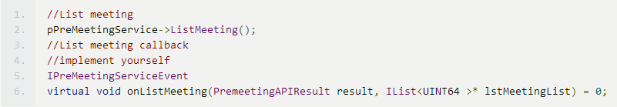

- Get meeting item by ID

Refer the header file for the details.

- Destroy Pre-Meeting Service

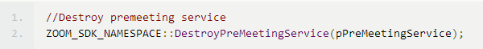

Meeting Service

If you want to use this service, include meeting_service_interface.h.

- Create meeting service
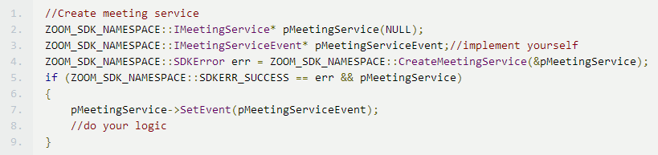
- Destroy meeting service
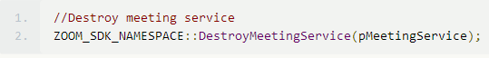

Meeting controller

- Start meeting for API user

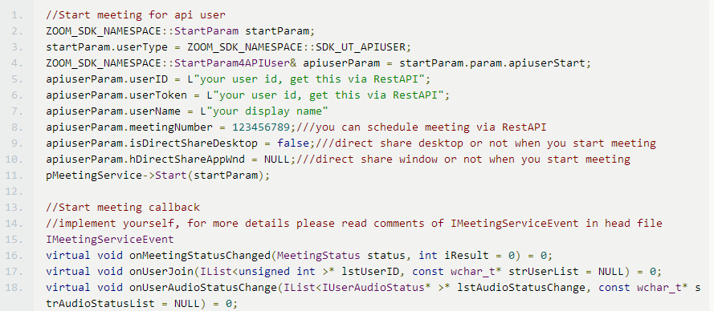

- Start meeting for End user
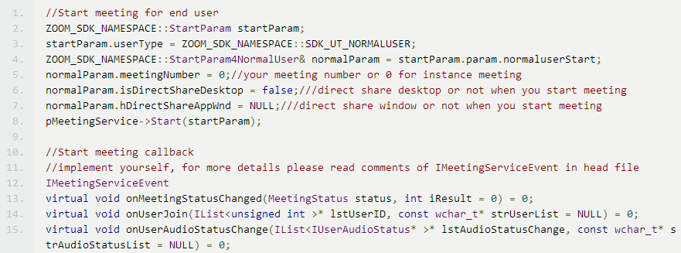

- Join Meeting for API user
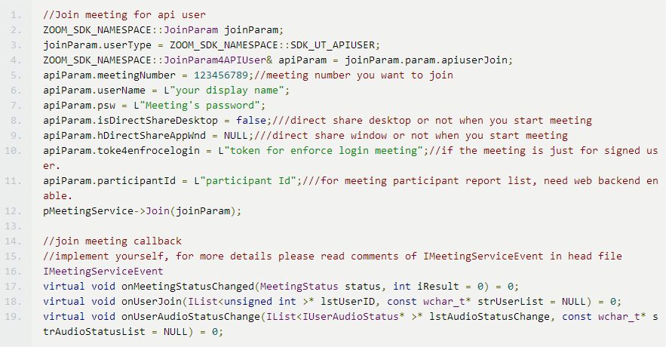

- Join meeting for end user
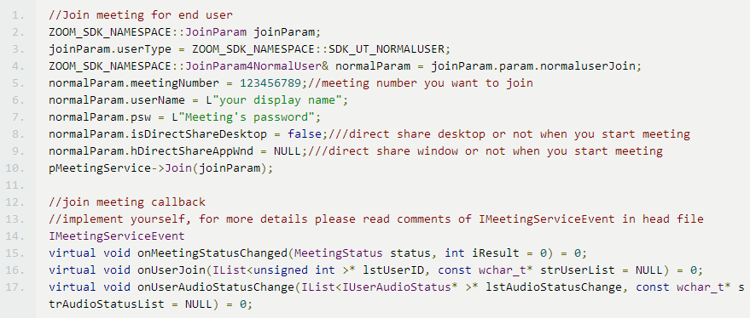

- Other interfaces
Please refer the Zoom SDK.chm

Meeting UI controller

You can get this controller after you have been in the meeting. If not, you can’t use this controller.

- Usage
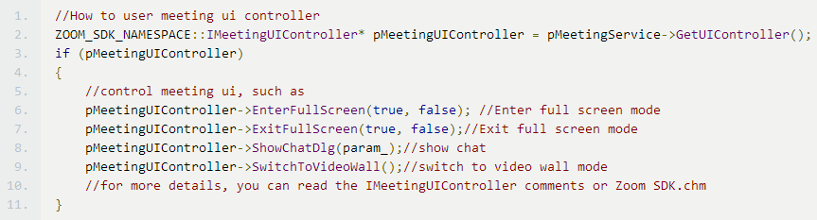

Meeting Configuration controller

You can set configuration before you call start/join meeting API. And if the meeting is ended or left, the configuration will be reset automatically.

- Usage
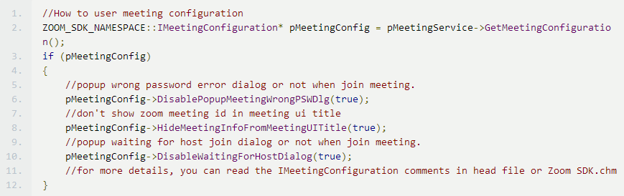

Meeting Annotation controller

You can get this controller when someone or you are sharing. If not, you can’t use this controller.

- Usage
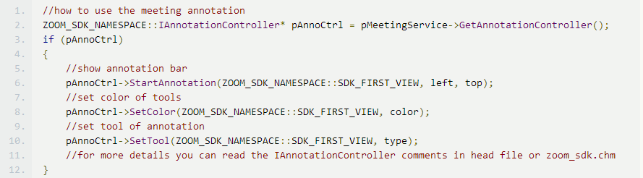

- Meeting Event

All of meeting event define at IMeetingServiceEvent. You can refer the header file or Zoom SDK.chm

Setting Service

If you want to user this service, include setting_service_interface.h.

- Usage

